# Problems faced during assignment

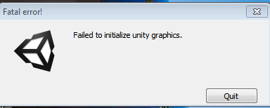

## Problem1: When saving the scene in unity



## Problem2: When I quit the game.

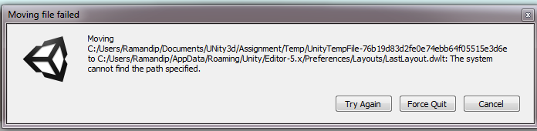

## Problem3: During game, my Drive was getting full, and all the data was being lost due to no space. C:\Users\Ramandip\Pictures\lab4\CDriveFull.PNG